File sharing on windows

Step by Step process to share files, videos, or even printers on windows. Assignment #4. By Esirigho Otite

Git-GoTech

Systems Engineering 401

**During my last interview, I was asked if I knew how to share files amongst my teammates? How to add a system to a domain controller (Host to Client sharing file process)? Ans: First I pointed out the functionality or advantages. See below:**

**Files sharing functionalities:**

* **It’s convenient**. With the windows tools, you can easily store & share your files with whoever and whenever you want to; all the users can remotely access all data and software from their computer.
* **It improves collaboration.**Collaboration gets much easier when you have a dedicated spot in the network that can be accessed as a team.
* **It’s cheap.** Cost-cutting is actually one of the main reasons why organizations choose to adopt file.
* **It’s secure**. It is easy to give access to your files, set up different levels of permissions to specific files and track their use - including any changes made.

**Here are the key few steps.**

1. One of your systems that has **Active Directory** can be the Host. First go to the client, make sure the client can ping that host by name and by IP address.
2. Then go on the client and make sure that the IP address of the client is static.
3. Make sure the domain, the DNS or the *domain name service* for that client is pointing to the box that has Active Directory, which is the host.
4. Set up the Host.
5. Now go to the client, and open server manager.
6. Click on local server and then click on the domain which is going to be logged showing now as workgroup; click on that work group.
7. Make sure you choose to change the domain. Change it and put the domain update host. Save it.
8. Apply then OK to be sure it's working.
9. Come back to your Host. Click and open *server manager* and click on tools; on the tools for Active Directory select users and computers.
10. When it opens, you'll see the domain because they can have multiple domains.
11. Click on the arrow next to domain to run it down. Click on the computer.
12. It tells you all the computers you're connected to.
13. Everything happens to the client from the client side.

**Identify which of your boxes is the Host and which box is your client.**

The easiest way to identify the Host (the on with Active Directory) is by 1st checking the login screen to see if it just shows “Administrator” or “User\Administrator”

Second if we go in Server Manage under tools click on the Active Directory Users and Computers

Below we see that the domain is otite.git-gotech.pro. We can change this to otite.local.

Since I did not change my computer name, I have to use the long “WINACISFAQ6OG” name ☹. Also since this already has AD on the system, if I change the name of the computer it will give me the error message “The security database on the server does not have a computer account for the work station trust relationship”

I can change the domain name search System Properties 🡪 existing domain name🡪 now we named it otite.local. I will reboot my system so Active Directory gets the updated DNS information.

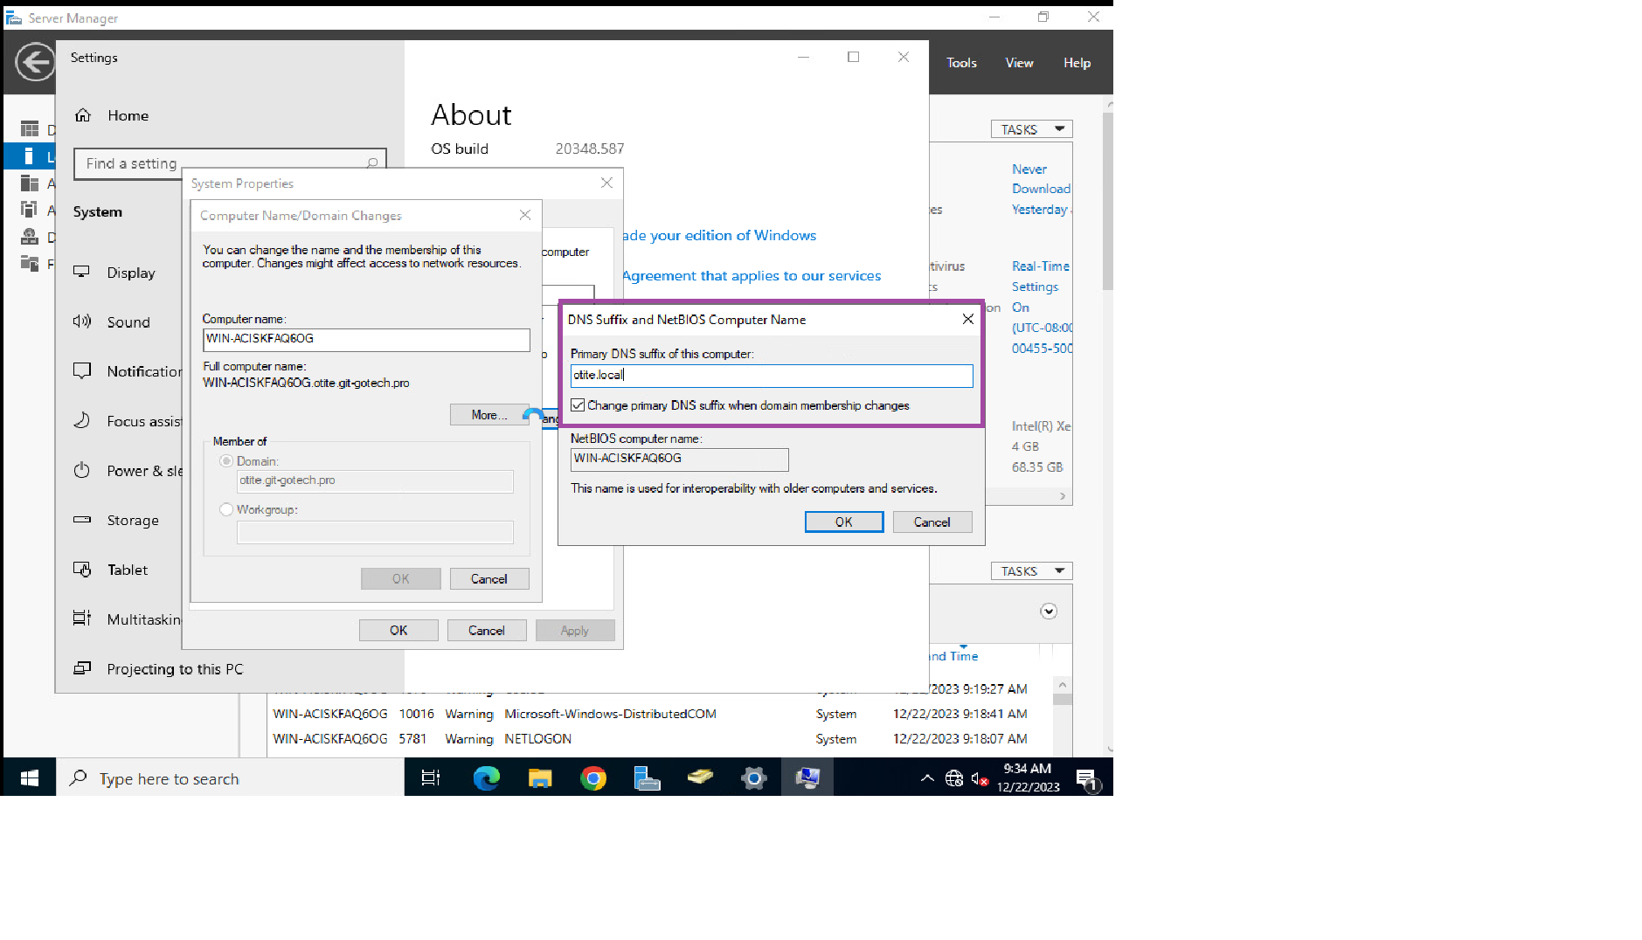

Now check that your IPV6 is disabled and the IPV4 properties are static:

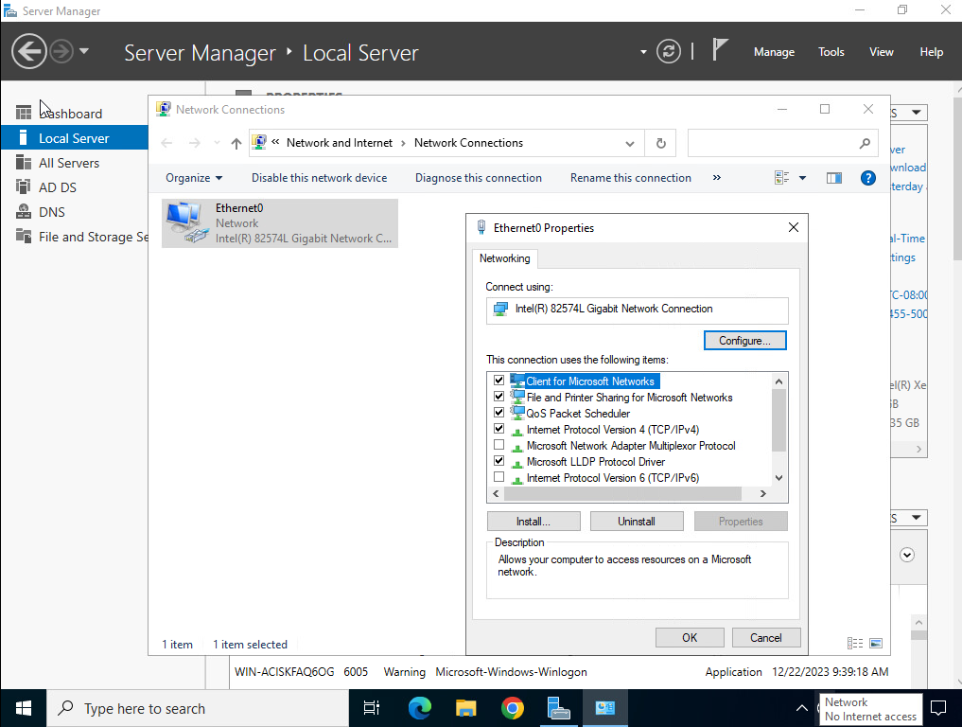

Check your network connection to make sure you are online:

**Now check the Client side of the connection:**

**Create all related folders and documents you want to share.**

**Client side:**

After all the setup is completed now access the files by clicking “Network” in file explorer:

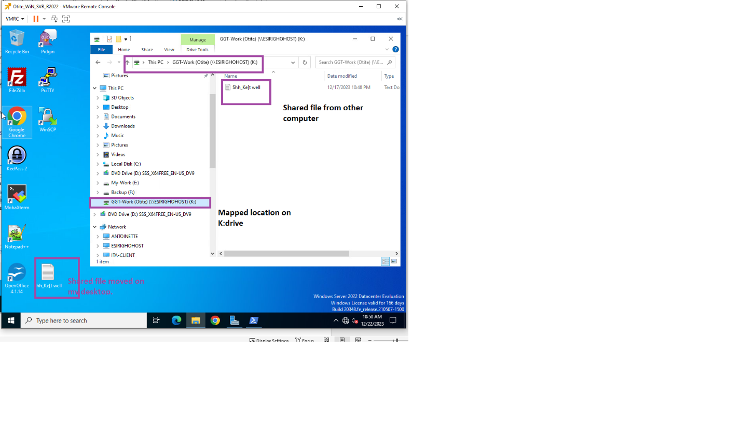

**Do the same from the other computer:**

Go to file explorer then click on “Network”

Select your computer name:

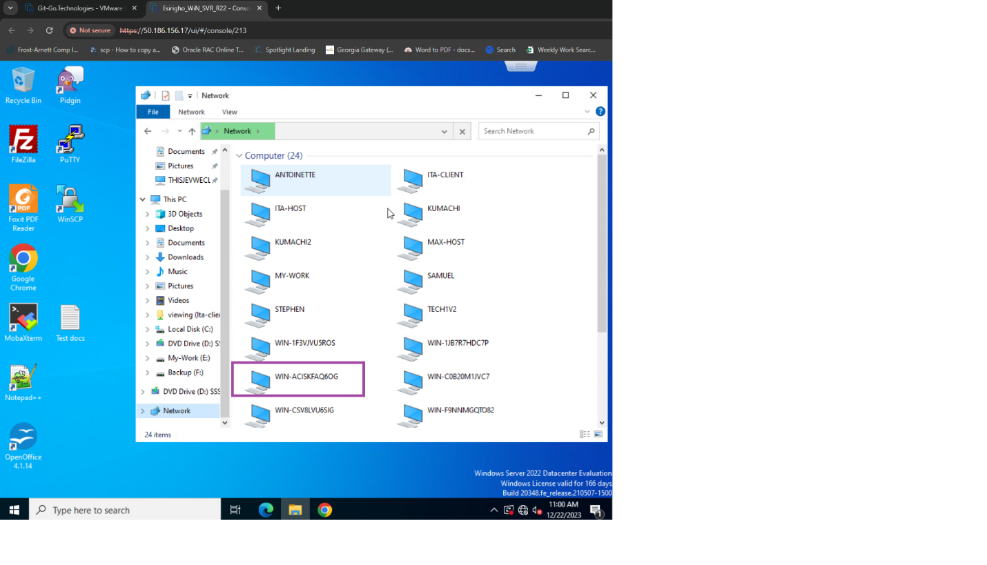

Under my working folder:

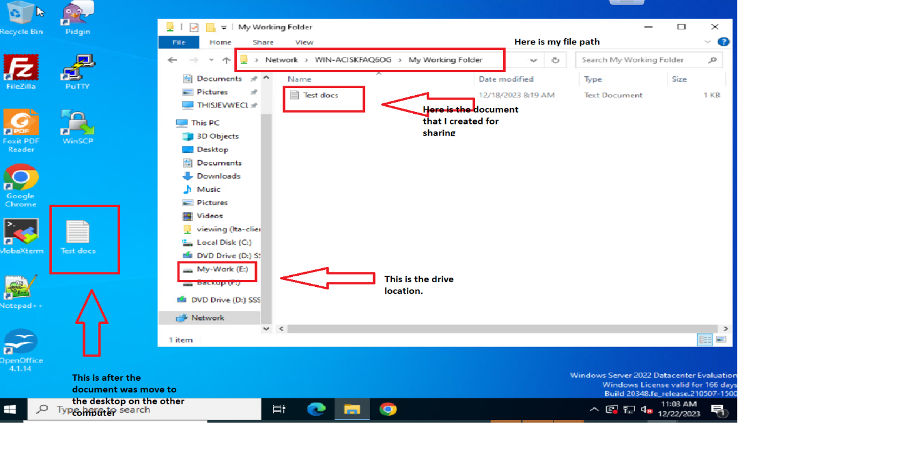

This concludes the sharing process. Thank you.